**Task 16 output**

1. Selenium script that opens the firefox browser window and navigates to google.com.

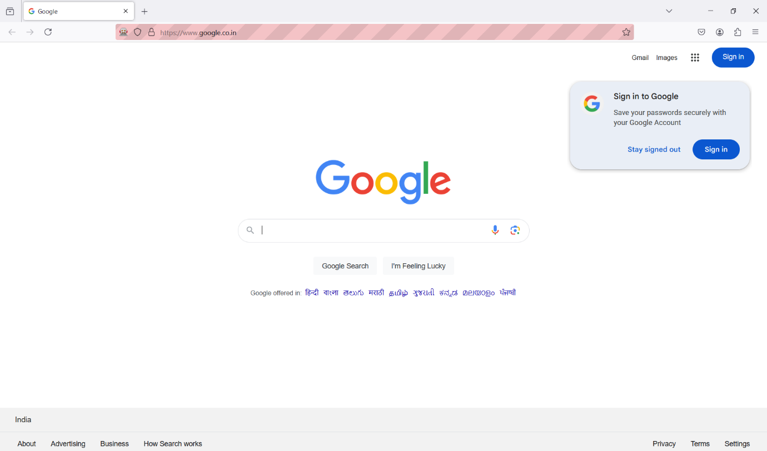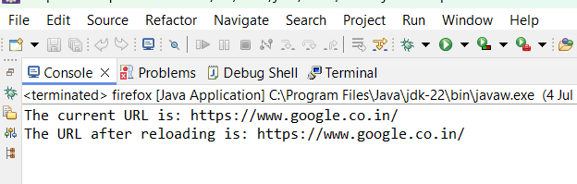

1. Selenium Script that open chrome browser to navigate to demoblaze website and do the following instructions.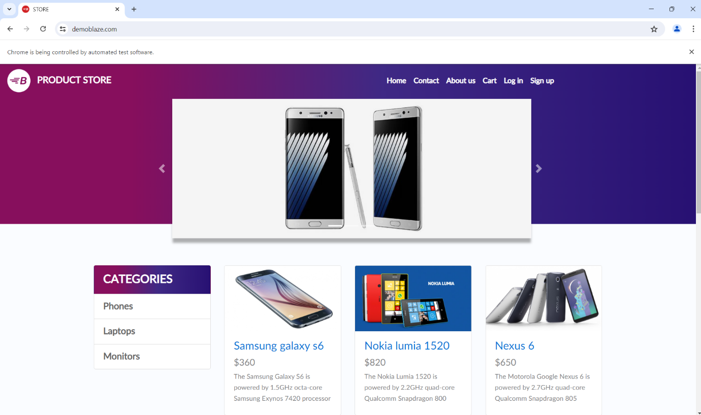

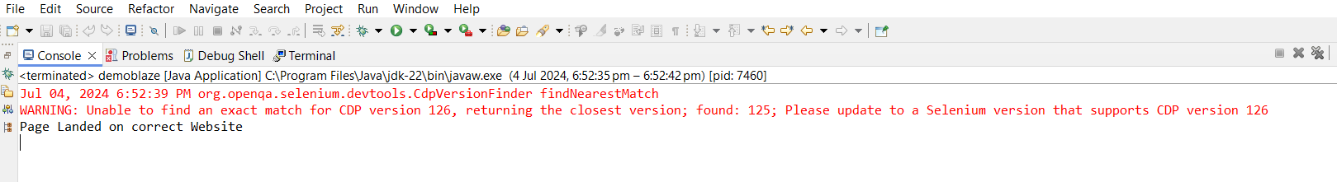

1. Open wikepedia and navigate to the History browser.

